**LAB2: AWS Identity and Access Management (IAM) - User, Role, and Group Management**

**1.Login to the AWS console with the root credentials> personal email ID & password**

**2.Authentication required > enter the MFA code from the authenticator app(which is installed on the phone either Google authenticator or Microsoft authenticator)**

**3.Type IAM in the Global search as shown below**

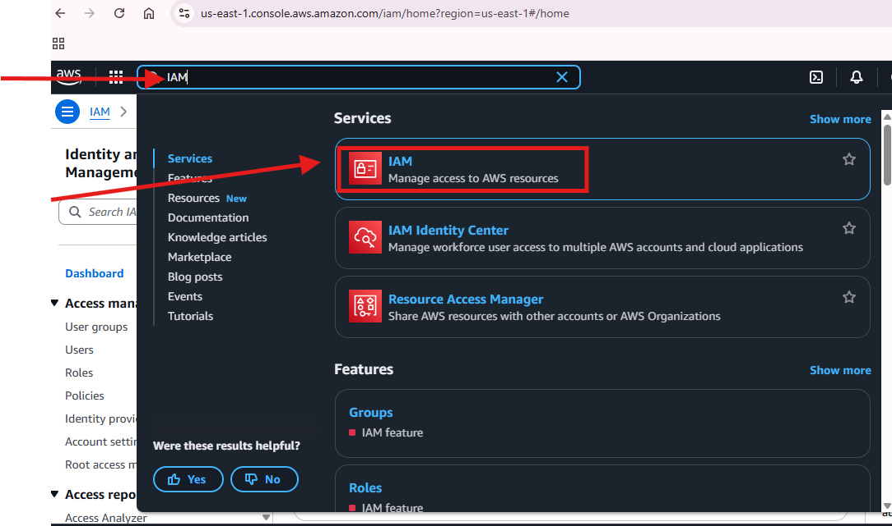

**4. Create a New Group which is shown on the left sidebar click on “usergroups”**

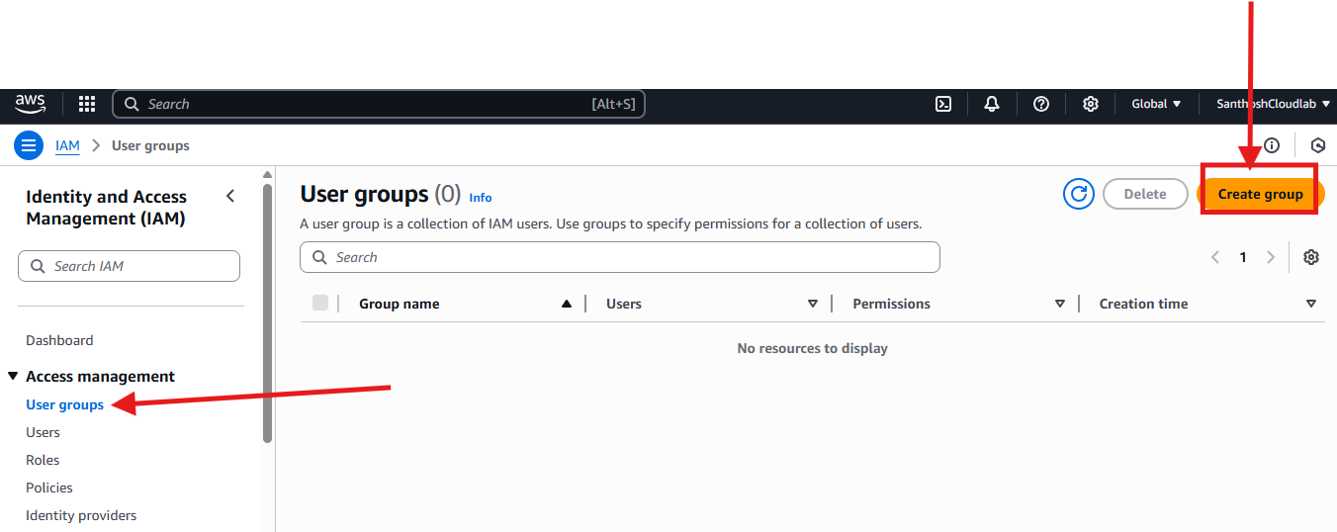

**5.Name the group- “DevelopersGroup”** and Attach the permission policies to group (AdministratorAccess+AmazonEC2ReadOnlyAccess+IAMReadOnlyAccess) and create the group (as shown In 2nd image below)

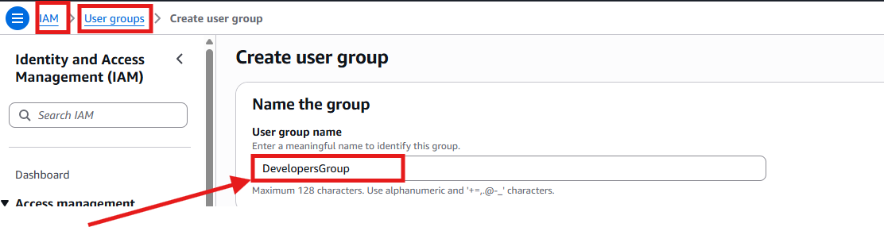

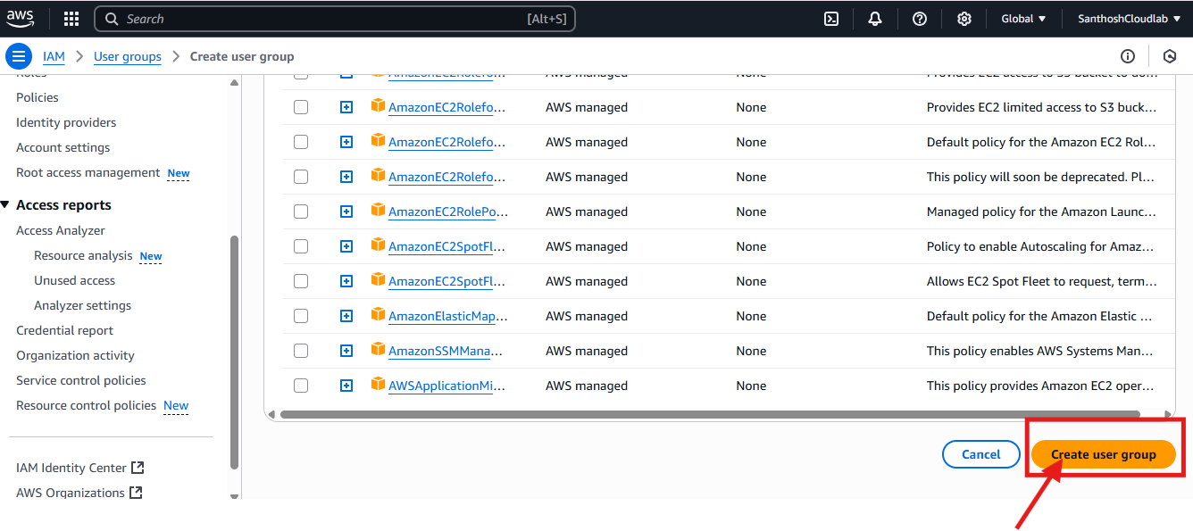

**6.After creating the group we can view the Group permissions**

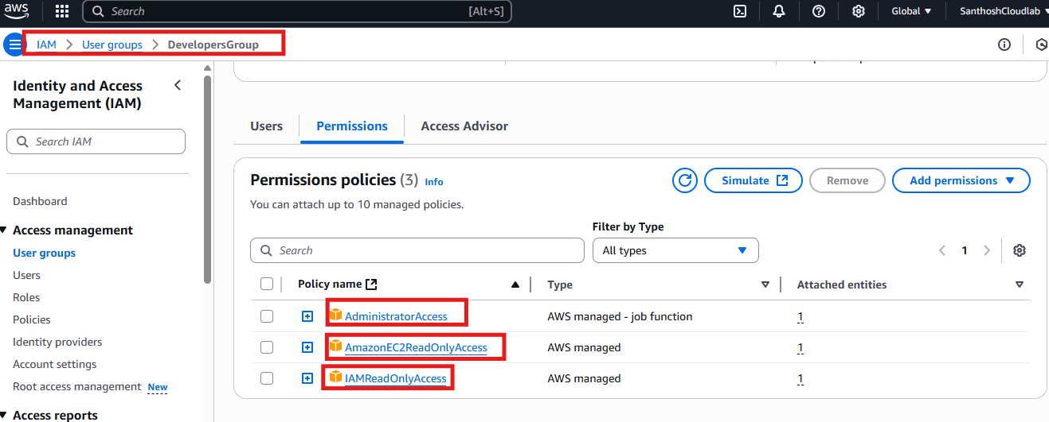

**Create IAM User**

**1.create the user first by clicking on the Users option under the Access Management**

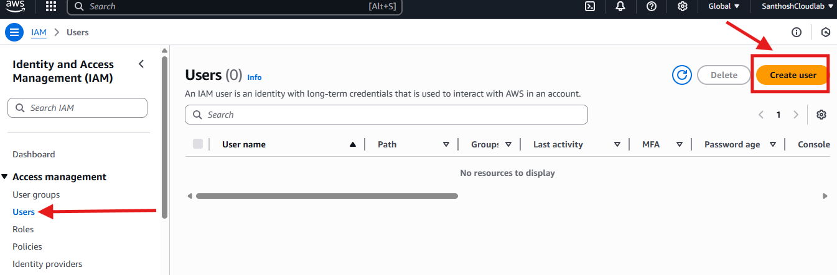

**2.Enter the user’s name in the username field – Provide user name as “Developer-Sanny” and click on next**

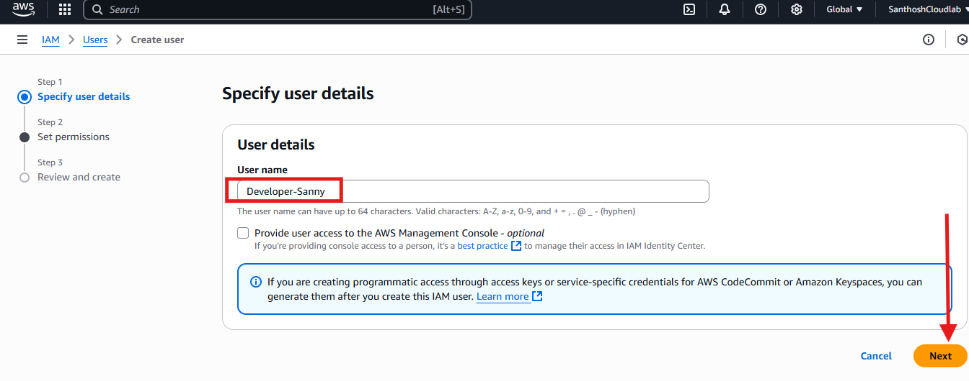

**3.Set permissions- under set permissions select the option “Add user to the Group” and under User groups select the one created earlier “Developers group”and then…click on next**

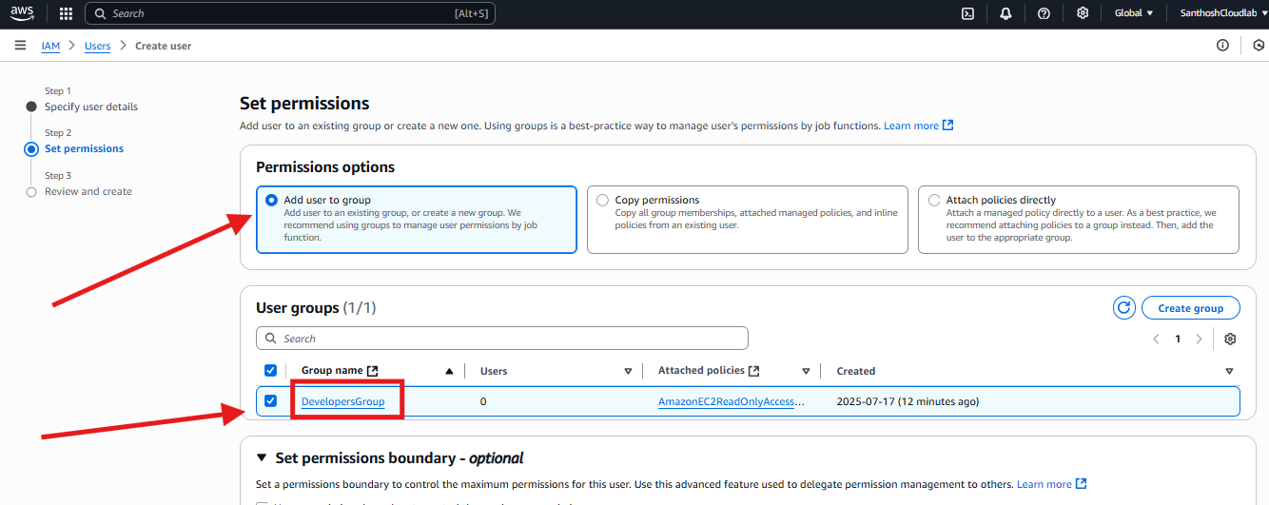

**4. Review and create -click on create user**

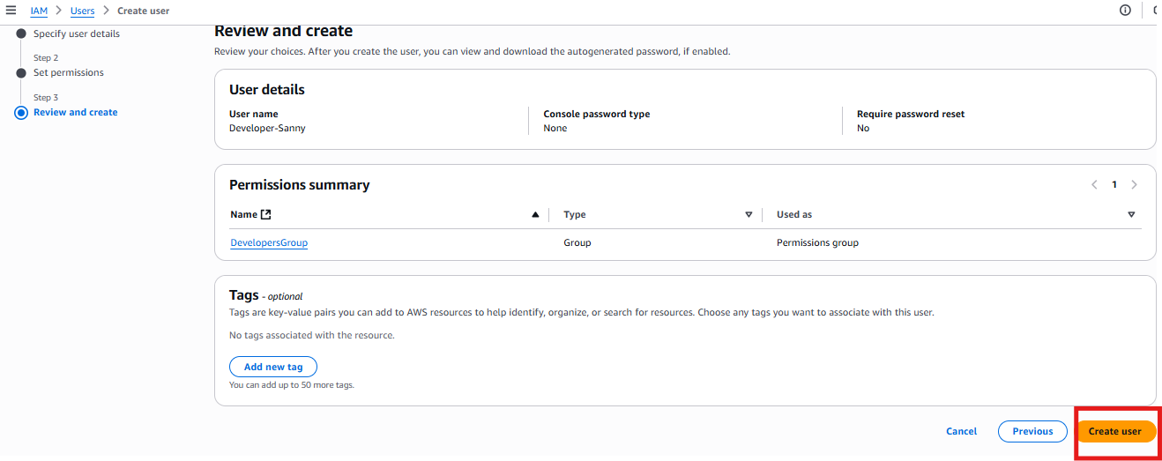

**5.click on the created user “Developer-Sanny” and go to Security credentials >select enable console access.**

**A pop up would appear- select autogenerated password and download the .CSV file which contains the password**

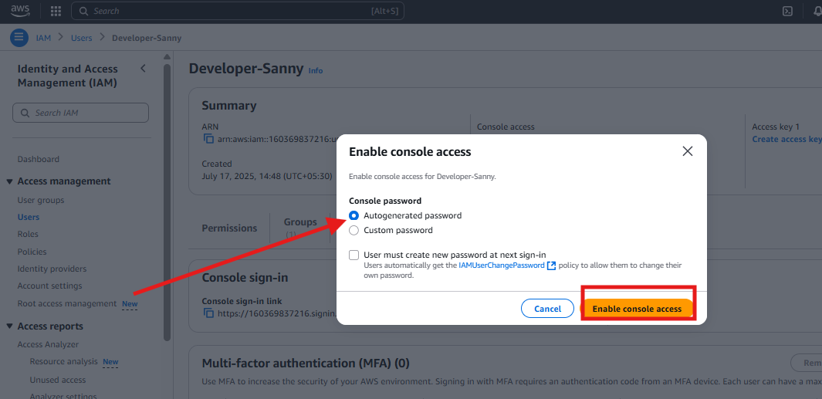

**6. user would be added to the group- “DevelopersGroup”**

**7.we can add Tags for the users**

**Click on Developer-sanny user >click on the 3rd option from below after permission and group option >Add new tag**

**Image below shows the key and value where key -“Department” value “Development” later save changes**

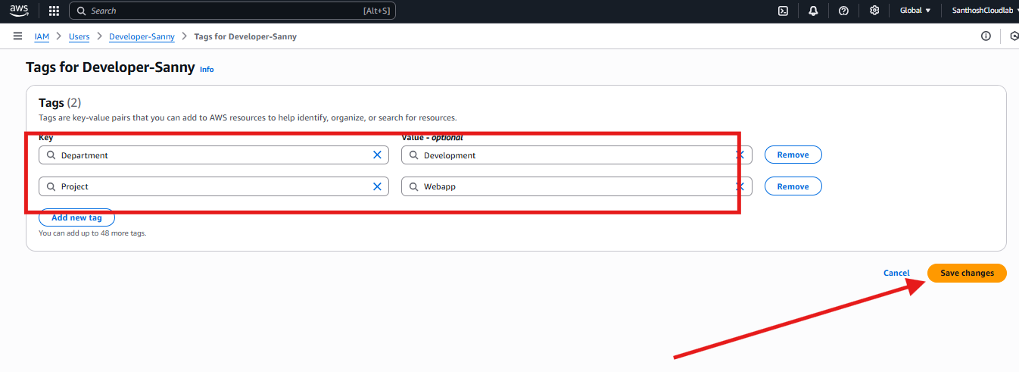

**IAM ROLE**

**1.Click on the Roles option under Access Management and click on create role as shown below**

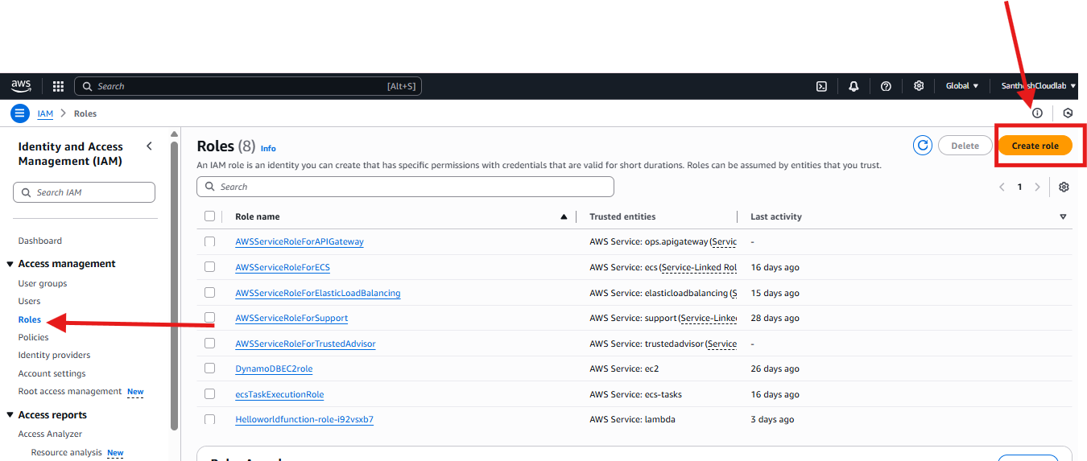

**2. select the AWS service and use case is EC2- click next after selecting service and use case**

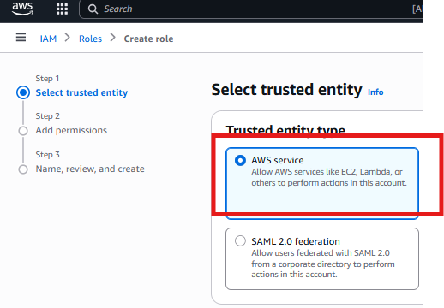

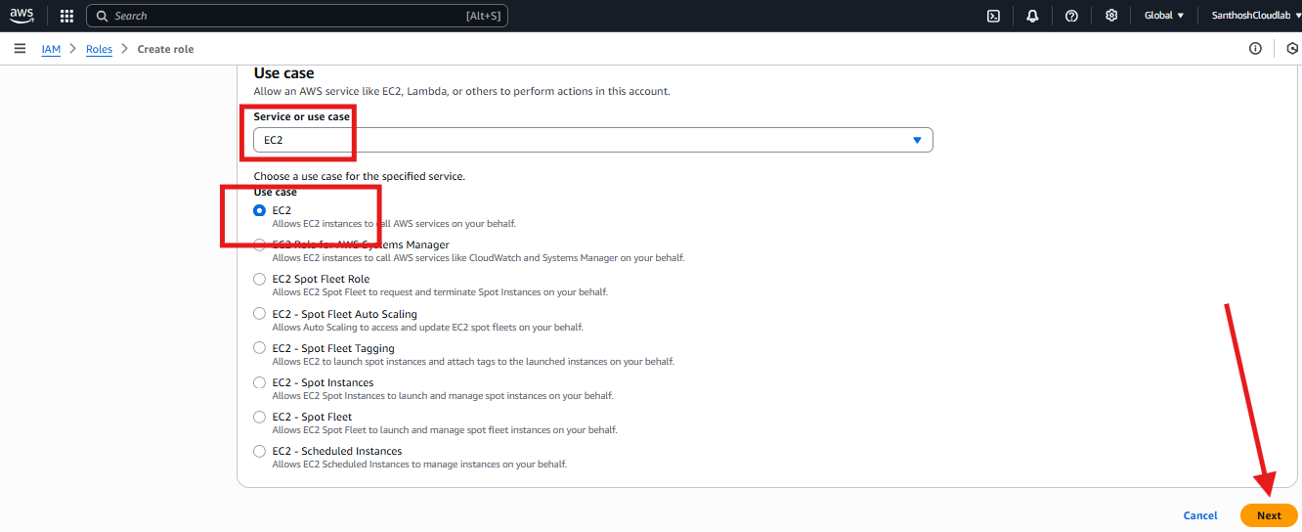

**3.Add permission- Add S3 read only access**

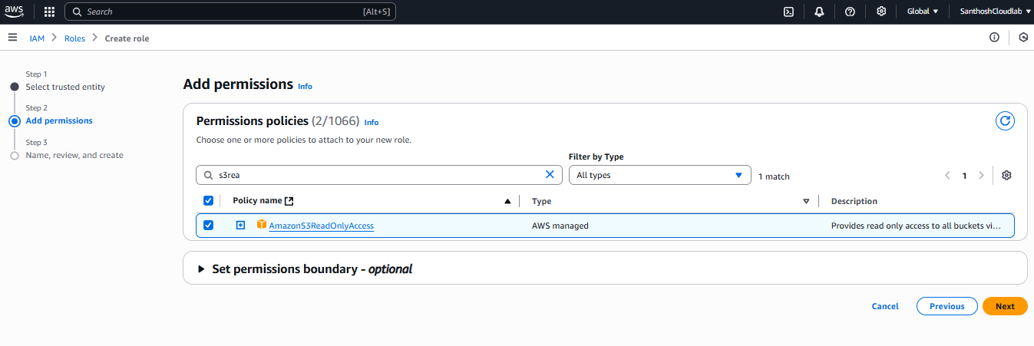

**4.Name of the Role and review +create**

